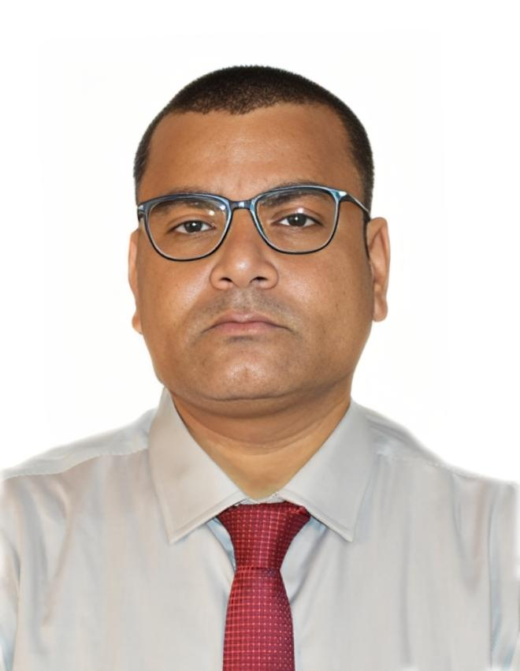**NAME: Pranav Kumar**  **D.O.B.: 08.08.1987; AGE:** 37

**Contact No: +91-9334322352/9693218910 Email ID: pranavgupta.in@outlook.com**

**Objective:** To enrich organization by implementing management skills experiencing as per

optimal global standards by maintaining professional requirements with proper execution.

5+ years experience in customer relationship and account management. Adept at marketing automation and Salesforce automation. Proven track record of reversing customer pain points, especially during checkout. Team-player and an enthusiastic go-getter. Outgoing individual with a pleasant personality.

I have been experienced and worked as Acquisition Sales Manager Au Small Finance Bank Ltd. Relationship Manage HDFC Bank Ltd., Sales Manager, Axis Bank Ltd. Senior Executive, and executive JVL Agro Industries Ltd, Business Development Executive, Genxbio Health Sciences Pvt. Ltd.

|  |  |  |  |
| --- | --- | --- | --- |
| **EXPERIENCES 10 Years and 5 Months** | | | |
| **Work Experience (3 Months)** | | **BP Securities Pvt Limited. ( Instant Funds ): Start up April 2024- Till July 2024**  **Designation: Team Leader (Tele-callers) + 15 Agents**  **Job Assignments:**   * Sales Expertise: Utilize your extensive sales experience to provide guidance, coaching, and mentorship to the telesales team. Share best practices, sales techniques, and product knowledge to help the team meet and exceed sales targets. * Pressure Handling: Demonstrate your ability to work effectively under pressure. Ensure the team remains focused and productive even during peak demand periods. Implement strategies to manage stress and maintain a high level of team performance. * Sales Opportunity Identification: Continuously assess the market and identify new sales opportunities. * Develop strategies to capitalize on these opportunities, such as targeting specific customer segments or introducing new products/services. * Data Analysis with MS-Excel: Utilize MS-Excel to analyze sales data, track team performance, and generate reports. Extract valuable insights from data to make informed decisions, optimize processes, and improve sales strategies. | |
| **Work Experience (1 Year & 8 Months )** | | **Aspire Ladders (Start UP). August 2022- March 2024**  **Designation: Freelance Recruiter**  **Job Assignments:**   * To manage and schedule interview as per requisite. * Do mining about employable employees search on various explorer. * Delivering consistent success in achieving all the hiring targets and objectives. | |
| **Work Experience (9 Months)** | | **AU Small Finance Bank Ltd.** November, 2021- July 2022  **Designation: Sales Acquisition Manager**  **Job Assignments:**   * To empanel DSA, Channel partner, CA across region. * Conduct meeting and activities on various aspects of banking and update product.   To manage leads under secured loan products for Working Capital Loan, and other cross sell like Insurance, CASA. | |
| **Work Experience (5 Months)** | | **HDFC Bank Ltd.** June, 2021- October 2021  **Designation: Relationship Manager**  **Job Assignments:**   * To coordinate with branch banking team for providing best services to customers. * Conduct meeting and activities on various aspects of banking and update product. * To manage leads under secured loan products for Working Capital Loan and other cross sell like Insurance, CASA. | |
| **Work Experience (3 Years & 7 Months)** | | **Axis Bank Ltd.**  September, 2017- March 2021  **Designation: Sales Manager- Farmer Funding**  **Job Assignments:**   * Team supervision and training of products under assigned subordinated branches. * To coordinate with branch banking team for providing best services to customers. * Conduct meeting and activities on various aspects of banking and update product. * To manage leads under secured loan products for B2C: Loan against property, Overdraft, KCC, Gold Loan and other cross sell like Insurance, CASA.. | |
| **Work Experience (05 Months)** | | **JVL Agro Industries Ltd.** April - September 2017  **Designation: Senior Executive- Sales & Marketing (Operation)**  **Job Assignments: To maintain & enhance rice division of the organization.**   * To manage commodity arrivals and their parity for all the channels. * Order Processing –ensure all orders get dispatch under valid period. * Get work optimize with internal account as well external sales teams, & commercial activity. * Ensure tasks are escalated MIS (Daily, Monthly & etc.) with top management as required. | |
| **Work Experience (2 Years & 4 Months)** | | **JVL Agro Industries Ltd.,** June, 2015 – March, 2017  **Designation: Executive-Sales & Marketing** **(Operation)**  Job Assignments: To maintain & enhance rice division of the organization.   * Analyse commodity arrivals and commercial activity. * Manage brokers, accounts against parties and update sales team. * Reporting and liaising MIS (Daily, Monthly & etc.) with top management. | |
| **Work Experience (1 Year)** | | **GenxBio Health Sciences Pvt. Ltd.,** May 2012-April 2013  **Designation: Business Development Executive**  Job Assignments:   * To do marketing of biotechnology research consumables across institutions. * To promote technical research based on trends and demand across industry related. * To manage account receivables and team associated to make organizational outcome. * To generate consumable requirements across institutions of research consumables and related products | |
| **EDUCATION AND ACADEMIC ACHIEVEMENTS** | | | |
| **Post – Graduations** | | **I.M.S. Banaras Hindu University, Varanasi 2013-2015**   * MBA (AB) Marketing   **University of Rajasthan, Jaipur 2010-2012**   * M.Sc. Biotech | |
| **Graduation** | | **University of Rajasthan, Jaipur 2006-2009**   * B.Sc. Biotech | |
| **Schools** | | **UPRAS Vidyalaya, New Delhi 2005**   * SSC, CBSE Board, Delhi   **S.K.P. Vidya Vihar, Banka; Bihar 2002**   * HSC, CBSE Board, Delhi | |
| **AWARDS AND ACHIEVEMENTS** | | | |
| ---------------------------------------------------------------------   * Qualified and ranked 8th in All India BHU PET 2013 cum the combined merit index, GD & PI for admission /interview for **MBA Agribusiness** conducted by Faculty of Management Studies, Banaras Hindu University, Varanasi. | | | |
|
| **SKILLS** | | | |
| **Technical** | * Leads management, Technical loans, and other financial products * Data mining,B2B& B2C Sells, cross sell products * Working in open/MS Office, Google Excel and other tools * Proficient in window Operating System XP/2007/8.1 | | |
| **Soft Skills** | * Customer relationship management (CRM), Client Service * Effective Communication, open to learning and adaptable. * Team player, positive attitude, multi-tasking. | | |
| **LINGUISTIC SKILLS** | | | |
| * English | | | * Hindi |
|  | | | |
|  | | | |

**Date: 08/07/2024**

**Place:** Noida

**(Signature)**