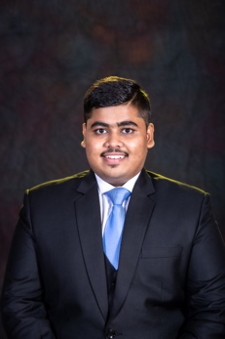 | Hardik Khyalilal Jain |  |  |  |  |  |  | 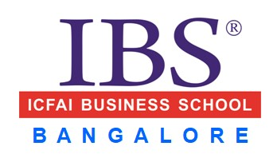
 | An ambitious and driven MBA candidate pursuing my degree at ICFAI Business School Bangalore, with a strong interest in securing a Sales and Marketing Position in your esteemed organisation. With a passion for strategic planning, market analysis, and building strong customer relationships, I am eager to apply my academic knowledge and practical skills to drive revenue growth and contribute to the success of a dynamic organisation.
Email ID:  hardik_jain22@ibsindia.org  Phone No: 9619031948 |  |  |  |  | EDUCATION
 |  |  |  |  | Course & Specialization | College/Institute or Board/University | Year of Passing |  | % Marks / CGPA
 |  |  |  |  | MBA | ICFAI Business School Bangalore | 2024 |  | Sem 2- 6.42
LinkedIn:  https://www.linkedin.com/in/hardik-jain-84b1aa212/ |  |  |  |  | BSc IT | Mumbai University | 2022 |  | 75.61%
 |  |  |  |  | XII Std | Maharashtra State Board | 2019 |  | 53.06%
 |  |  |  |  | X Std | Maharashtra State Board | 2017 |  | 70.60%
DOMAINS |  |  |  |  | SUMMER INTERNSHIP (February to May 2023)
Marketing  IT |  |  |  |  | Title: Acquiring New Clients & Assisting in Business Expansion for  smartSense Solutions- Home/Office Automation Product.  Company: smartSense Consulting Solutions Pvt.Ltd  Description: As a Business Development Executive, I gained experience in market research, digital marketing, and business development. Developed skills in market analysis, lead generation, digital campaigns, and client relationship management.  Key Responsibilities:  - Business Development.  - lead Generation.  - Market Research.  - Marketing Analysis.  - Digital Marketing.  - B2B Marketing.  - Sales and Marketing.  - Customer Relationship Management.  - Social Media Analysis.  - Search Engine Optimization.  - Digital poster Design.
SKILLS
Graphic Designing,
Video Editing,
Ms Excel(Basic),
Ms Word,
PowerPoint Presentation,
Market Research

INTERESTS |  |  |  |  | ADDITIONAL QUALIFICATIONS & CERTIFICATES
Travelling  Swimming  Cooking  Football |  |  |  |  | - Certificate in HTML Fundamental Course from Sololearn in 2020.  - Certificate of Digital Marketing from HubSpot Academy in 2023.  - Certificate in National level Research Paper Conference in College competition in 2022.  - Certificate in Search Engine Optimization (SEO) from HubSpot Academy in 2023.
LANGUAGES |  |  |  |  | OTHER PROJECTS UNDERTAKEN
 |  | S | R | W
English
Hindi
Gujarati
Marathi
Marwari
PERSONAL INFO |  |  |  |  | ACHIEVEMENTS
DOB: |  | 14/09/2001 |  |  | - Won second prize in a Tantravihar (Electro Shoes and GPS System) (IoT Project) competition in July 2022.  - Point of Contact (POC) for LinkedIn in DA (Digital Ambassador) club at IBS Bangalore.  - Member of the student council in graduation.  - Maharashtra State Certificate in Information Technology (MSc IT) with 92%.  - Letter of Appreciation for Summer Internship.
Domicile State: |  | Maharashtra
Address for Correspondence:
Room No: 34, 2nd floor, Bahari Building No: 2, JB Road sewri, Mumbai- 400015

