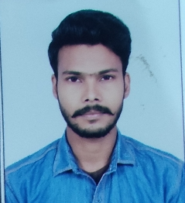
MOHAN KUMAR
Mailing Address
VILL :-MOBARAKPUR, P.O:-CHANPUR, Gmail :- mrmohankumar0007@gmail.com
P.S:-SISWAN, DIST:- SIWAN , (Bihar) 841203 Mob:- 9661241443

Objective
Want to in competitive and challenging environment to contribute best of my ability and
knowledge towards growth and development of progressive company.

Education Details
- Matriculation from BSEB, Patna. (2017)
- Intermediate from BSEB, Patna. (2019)

Computer knowledge
- Tally, Ms Word, Ms Excel, Power Point, Adobe PageMaker, Adobe Photoshop,
Video editing, Internet, etc…

Other course
- ADCA in Computer.
- KYP in Computer.
- Courier delivery executive (DDU-GKY)
- Mobile Handset Repair Engineer Level-II- English (RPL)

Personality
- Honest and Sincere
- Optimistic and try to create maximum

Personal Profile
Name : MOHAN KUMAR
Father’s name : SRI RAMJULM CHAUHAN
Mother’s name : BINDA DEVI
Date of Birth : 12/05/2001
Gender : Male
Marital Status : Unmarried
Nationality : Indian
Religion : Hindu
Language : Hindi, English
Hobbies : Play cricket, Mount Climb, Swimming, and Internet Browsing

Declaration:

I hereby declare that the above mentioned information is correct up to my knowledge and
I bear the responsibility for the correctness of the above mentioned particulars.

Place: (MOHAN KUMAR )
Date: Signature

