CURRICULUM VITAE
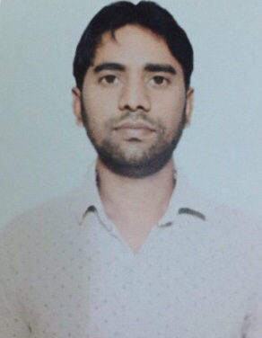
VICKY GIRI
Mobile No:- 08882055074
E-Mail:- vicky_giri55@rediffmail.com

Objective:
“Looking for a challenging role in an organization, which provides opportunities to enhance my skills and expand my knowledge for the growth of the company.”
Skills:
Interpersonal skills, Time Management skills, Reporting, Adaptability, Sales order Management
Tools:
Ms-Office, ERP Navision (9.0), Outlook Express, Internet, Social media
Educational Qualification:
Bachelor of computer application (BCA) from Bareilly (U.P)
Intermediate, High School from U.P Board Allahabad
Professional Experience:
M/s Superon Schweisstechnik India Ltd. - Manesar (June 2012 to-Nov 2017)
Company Profile:
Superon Schweisstechnik India Ltd. established in 2004 is one of India’s largest manufacturers & exporter of Welding Consumables & Stainless Steel Wires. Superon Schweisstechnik India Ltd. has made a mark in India, and also has been successfully exporting its products, to over 70 countries.
Designation: Store Assistant
Responsibility:
Sales Order Responsibility:
✦ Reporting to Head Office on daily basis, making MIS thru MS-Excel & ERP.
✦ Daily reporting to HOD and Production team for Material against Sales Order.
✦ Coordinate with export and domestic sales team to Dispatch the samples.
✦ Sample packaging coordination.
✦ Daily reporting to H.O regarding complete orders, dispatched order, pending orders.

Responsibility with Dispatch team:
✦ Coordination with Dispatch team to Dispatch the material against billing.
✦ Check the material Quantity against invoice.
✦ Coordinate with sales team to ensure dispatches as per daily dispatch plan.

Responsibility with Store team:
✦ Indenting of raw material, packing material, New Item and other required material.
✦ Receiving and sending couriers.
✦ Coordination with Purchase team regarding purchase orders of raw material and other items.
✦ Weekly Track supply monitoring form against received and pending material.
✦ Physical Stock vs ERP Stock checking monthly

Credentials:
✦ Previous Salary: 2.8 lac
✦ Expected Salary: 4.5 lac
Personal Details:
Father’s Name: Sh. Buddhi Giri
Date of Birth: 26-Feb-1988
Nationality: Indian
Languages Known: English & Hindi
Marital Status: Married
Hobbies: Playing chess
Strength: I can adjust myself anywhere anytime. I learn by everything
Permanent Address: Village-Darela Po-Asafpur Disst-Budaun (U.P)
Reason for gaping: Study purpose

Declaration:

I hereby declare that the details given above are true to the best of my knowledge and belief.

Date:
Place: VICKY GIRI

