CURRICULUM VITAE
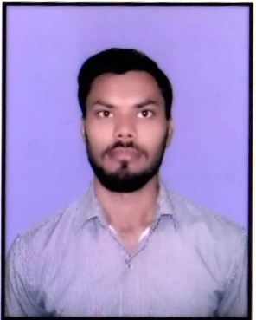

Sachin Kumar Singh

Chhoti Holi, Near Hanuman Mandir
Padam Singh Gate, Khurja-203131
Distt. Bulandshahr (U.P.)

Contact details: +91-7500099543, 8171020018
Email Id: tusharjadon11@gmail.com

Carrer Objects

To attain the peak of success with my hard work and potential in shortest possible time. To yield better work prospective to the organization, and a competitive working environment to my subordinates with full encouragement and whole-hearted participation.
Qualification Summary

- B.C.A. Passed from C.C.S. University, Meerut in 2015
- 10+2th Passed from U.P. Board, Allahabad in 2012
- 10th Passed from from U.P. Board, Allahabad in 2009

Exeperience

- Two Year 8 Month Experience as an Executive assistant in Creative Educational Aids Pvt. Ltd. In Soorajpur, near Pari Chowk, Greater Noida
- Two Year Experience as an Administrative (Admin & Excutive) in A.P.I.S. (BSR)
- 1.5 year Experience as Help Desk & Reception as a Shivam Technical Campus, BSR
- 3 years Buero Chief (for Advertisement) In Adarsh News, Bulandshahr (U.P.)
- 1 Year 2 Months Experience as CSA in Digi call Noida

Key responsibilities handled

* Monitoring the overall functioning of process.
* Management and Handling relationship with major corporate clients
* Self Motivated & Motivational Tips.
* Good Communication Skills
* To maintain client satisfaction and improvement.
* Problem solving skills and product knowledge through the Telecom center .
* Developed or implemented new procedures or systems.
* A great Prestation at work & please don’t belittle other people.
* Keep the Emphasis on your Hard Work.

Achievements

* Re-organized something to make it work better with the identified a problem
and solved it
* Add extracurricular activities:
Sports, Community service show your abilities and skills.
* Time Management, Stress Management
* Perfect attendances awards or bonus.
* Successfully headed the training program for one of the major BPO service providers.

Personal Details

Father’s Name: : Mr. Ram Kumar Singh
Date of Birth: : 01st April 1994
Languages known: : Hindi & English
Gender: : Male
Nationality: : Indian
Marital Status: : Unmarried
Strength: : Attractive & Impressive work
Weakness: : Angry & Shouting
Hobbies: : Listen Music & Cold weather walking
Family Members: : 5 Members (Include me)
Father Occurs: : Shopkeeper
Salary Expectation: : 30000+
Permanent Address: : Chhoti Holi, Near Hanuman Mandir,
Khurja-203131 Distt. Bulandshahr

Declaration

I do hereby declare that the particulars furnished by me above are true to the best of my knowledge and belief.

(Sachin Kumar Singh)
Place: Khurja Name/Signature

